30.16: a) free space: 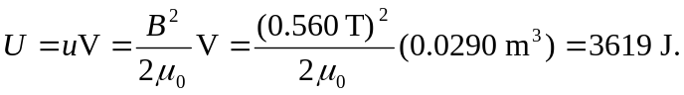
b) material with 